Winter Carnival 2021

February 11-14

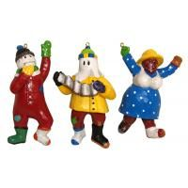

Schedule of Events

**Thursday, February 11**

4:30pm: Mummers Parade

Starting at Bonne Bay Cottage Hospital & Parade to the Town Hall

3:00 - Spaghetti Supper (Take-out)

5:00pm Lions Club $10

7:00- Teen Sliding Event 8:30pm (Gr. 7-12)

@ Visitors Centre

(Hosted by GMCC)

**Friday, February 12**

4:00 - Fire Up a Scoff (chip truck)

7:00pm: (Winter Carnival specials available)

4:30 - Scavenger Hunt

5:30pm: @ Visitors Centre

Hosted by Tuckamore Ski & Snowshoe Club

5:00 - Mooseless Madness Dinner

6:30pm: (Take-out) $10

@ Town Hall Hosted by BBSAR

6:00 - Headlamp lit Snowshoe

7:00pm: @ Visitors Centre

Hosted by Tuckamore Ski & Snowshoe Club

**Saturday, February 13**

9:30am: SNOWGA with Sonya

Family snowshoe followed by outdoor yoga @ Bonne Bay Cottage Hospital

11:00am- Free Skate

12:00pm Gros Morne Arena

Sponsored by the Town of Norris Point

12:00pm: Snowmobile/Poker Run

$5 a hand @ Lions Club

Leaves Lions Club @ 1pm

Soup & sandwich or 2:00pm chilli & Roll ($6.00)

Hosted by the 50+ Club

(Following Poker Run)

1:00pm: Family Sliding Fun

(Neddies Harbour Boat Launch)

2:00pm- Drive Thru Bake Sale

4:00pm Norris Point Fire Hall

Hosted by the Firettes

3:00pm Virtual Puppet Show

Hosted by Cedric Davignon

(Town Facebook Page)

Carnival Buttons

Purchase your carnival button for just $1.00 starting on February 1, 2021

Buttons available @ Town Office, Bonne Bay Pharmacy, C & J Rumbolt’s & Rudy's Gas & Convenience until 4:00 pm, Friday, February 12th.

Prize: 50% of the carnival button sales

The winning #'s will be drawn during the VOBB Bingo on Sunday, February 14, 2021 @ 7pm.

Snow sculpting Contest

From January 30 – February 12…enter a snow sculpture for a chance to win a prize!

1st prize $50

2nd prize $25

All are welcome to join in on the FUN!!

**Sunday, February 14**

9:00am: Town Walk

Start at the Bonne Bay Cottage Hospital to Bugden’s Cove and meet back at Town Hall.

1:00pm: Polar Dip

Virtual event!!

Hosted by Fire Department

2:00pm - Valentine’s Day Hunt

3:00pm: Town Hall Parking Lot

Hot Chocolate & Treat Provided

7:00pm Lions Club/VOBB Bingo

Purchase cards @ local stores

Tune in to 95.9 or 98.1fm

or [www.vobb.org](http://www.vobb.org)

(Button Draw)

*** Extra Activities ***

(See Town Facebook Page for Posters)

Slogan contest

Create a Winter scene contest

Carnival Selfie

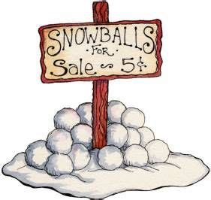

Special thanks to everyone who

hosted events, donated and helped to make Winter Carnival 2021 possible.