Merry Christmas


Town of Norris Point December 2019

Message from Our Mayor
Greetings from your Town Council and staff, wishing you and your family a Merry Christmas and a Prosperous New Year. May your year be filled with health and happiness. It is a time of year for celebrations with family and friends and a time for reflection of the events that occurred over the past year.
This past year three streets were paved, and the Asset Management plan for our Town was completed, which will prove to be very beneficial to the Town and its workers. There were also upgrades made with several lift stations. The Town purchased new helmets, gloves, jaws of life and “Who’s Responding App” for the Fire Department, this was very significant for their department. Phase three of our water line replacement will begin this coming Spring. There will be some interruptions in services so we apologize in advance for this. There have been great strides made in the reconstruction of our playground this past year, Thanks to the Recreation Committee.
The 2020 budget has been completed with no tax increase other than a couple of minor adjustments to our commercial business taxes.
Once again we wish you a Happy Christmas & Joyous New Year.
Mayor Joe Reid
Office Hours Closed on December 24th Office will re-open 8am on Thursday January 2, 2020
Emergency Contacts Clayton Hatcher 458-2011 Mayor Joseph Reid 458-2762 Jennifer Samms 458-2324

Norris Point Recreation Chase the Ace

Thursday Night 7-8 pm with the draw at 8:15pm at the Norris Point Town Hall

**All proceeds go towards the Community Park Enhancement
(Playground) project**
Special thank you to all the volunteers that have helped out or participated in any community events during 2019. Your help does not go unnoticed. Thank you!!
The Come Home Celebrations will be taking place July 24th – August 1st, 2020. Registration is open to all residents. Applications are distributed throughout the Town. Please contact the Chair – Susan Reid @ 458-2762 if you have any questions.
Holiday Schedule Town Garbage Collection Schedule (Ocean's Enterprises)
***FRIDAY, December 27th & Tuesday, December 31st, 2019 (Residents are responsible for ensuring their garbage box covers are secured following pick-up)
WRWM Transfer Site
Closed - Wednesday, December 25th, Thursday, December 26th & Wednesday, January 1st, 2020

Merry Christmas
& Happy New Year!!

Snow Clearing
We are now into the Winter Season and Snow Clearing Services are in effect. We would like to remind property owners that Council will not be responsible for property damages caused due to snow clearing operations. In areas where the by-roads and lanes are very narrow it is suggested that property owners place markers on the edge of their properties. Thank you!

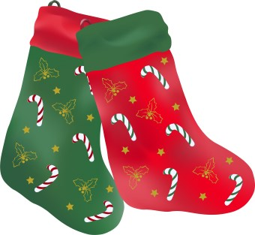

Playground
Planning and Fundraising efforts are underway for new renovations to the playground.




